Quarch Technology Ltd

PCIe Card Module + Triggering

Trigger on Host Power Up

For use with:

**QTL1688-04**

**Using Quarch firmware version 4.005 and above**

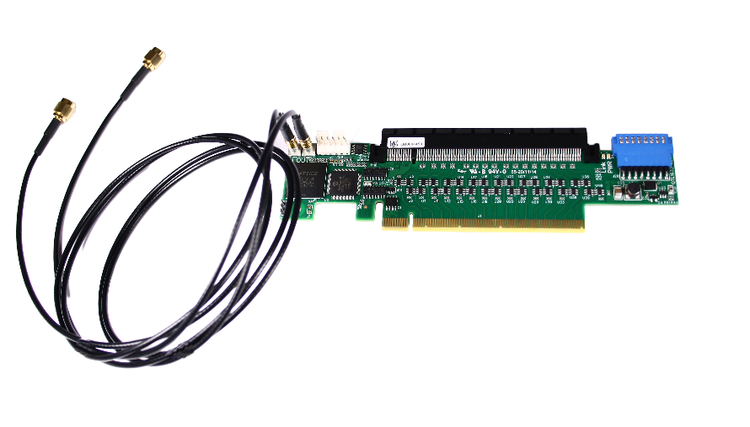

# Change History

|  |  |  |
| --- | --- | --- |
| 1.0 |  | Initial Release |
|  |  |  |
|  |  |  |
|  |  |  |
|  |  |  |

Contents

Change History 2

Introduction 4

Requirements 4

Set-up 5

Triggering on Host Power Up 7

The Basics 7

Triggering Example 8

Trigger a Power Margining Module to run a Pattern 8

# Introduction

Firmware version 4.005 has added the functionality to provide an internal and external trigger on host power up.

The external events are triggered by producing an output trigger to another device, either a Quarch device that supports triggering (for example a Power Margining Module) or a third party piece of equipment that allows triggering input.

This application note will focus on using a Quarch Power Margining Module to run a power pattern when the host powers up.

Since the trigger is iniated by the Host powering, a separate PC is used to control the modules.

## Requirements

* 1. Quarch PCIe Module which supports triggering on host power up:
  + QTL1688(-04 and higher)
  1. Quarch Power Margining Module which supports triggering
  + QTL1999(-01 and higher)
  + QTL1995(-01 and higher)
  + QTL1847(-01 and higher)
  1. Quarch Interface Unit
  2. Host PC
  3. Control PC (with drivers installed if using USB control)
  4. An appropriate script or terminal able to connect and issue commands

## Set-up

In order for the PCIe module to provide power to the card form the Power Margining Module rather than the host, a jumper must be put on the PCIe module.

Power Margining Module

PCIe Module

Host PC

Control PC

Interface Unit

Card Being Tested

Plug into

Plug

into

Plug

into

USB/Serial

Trigger cable

Output cable w. PCIe adapter / PCIe cable

USB/Serial/Lan

### Control Options

* TorridonTerminal can send commands to a module  
  <http://quarch.com/file/torridon-terminal>
* TestMonkey provides GUI control over a module  
  <http://quarch.com/file/testmonkey>
* Python can be used to automate control of Quarch products  
  <http://quarch.com/file/an-006-python-control-quarch-modules>

# Triggering on Host Power Up

## The Basics

The module can be configured to perform a number of actions when the Host is powered up:

* External: The module sends out a pulse along the trigger out port, if a cable is connected to this port the signal will travel to the device it is connected to and trigger an event on it according to that device’s configuration
* Internal: The following can be triggered on the module:
  + Hot Swap
  + Glitch

The module can listen to either of the hosts power lines:

* 12V
* 3V3

For the example given an external trigger will occur on 3V3 host power up

# Triggering Example

## Trigger a Power Margining Module to run a Pattern

First, we will create a power pattern for the card on the **Power Margining Module**:

#Zero the outputs

SIGnal:12v:VOLTage 0

SIGnal:5v:VOLTage 0

#Add a simple pattern to slowly ramp the 12V over 50mS

SIGnal:12v:PATtern:ADD 50mS 12000 i

#Add a pattern to the 5V channel which glitches 3 times

SIGnal:5v:PATtern:ADD 1mS 3000

SIGnal:5v:PATtern:ADD 2mS 0

SIGnal:5v:PATtern:ADD 3mS 3000

SIGnal:5v:PATtern:ADD 4mS 0

SIGnal:5v:PATtern:ADD 5mS 3000

SIGnal:5v:PATtern:ADD 6mS 0

#Set to run the pattern on an external trigger edge

PATtern:TRIGger:EXTernal ON

PATtern:TRIGger:EXTernal:TYPE EDGE

Next, we will set up the **PCIe Module**:

#Set the module to Trigger Out on 12V Host Power Up

TRIGger:OUT:MODE:12V_Host

Once the host PC is powered up, the PCIe Module will output a trigger that is received by the Power Margining Module which will run the pattern. The power output by the Power Margining Module will be fed back to the PCIe Module which will give that power straight to the card plugged into it.